In-Silico Pharmacological Modelling of mPGES-1 Inhibition by Rutin: A 3D Pharmacophore and Molecular Docking Pipeline
Introduction
The human inflammatory response is heavily mediated by the conversion of arachidonic acid into prostaglandins. Traditional painkillers i.e. the classical non-steroidal anti-inflammatory drugs (like Ibuprofen or Aspirin) block the upstream cyclooxygenase enzymes, COX-1 and COX-2. While this stops the pain, it also frequently results in severe gastrointestinal and cardiovascular toxicities by their broad inhibition. Instead of damning the whole river, what if we just blocked the specific toxic tributary?
Microsomal Prostaglandin E Synthase-1 (mPGES-1) is an enzyme further downstream in the arachidonic acid cascade whose only job is to create PGE_{2,} specifically by catalysing the terminal isomerization of PGH₂ into the highly pro-inflammatory PGE₂. Inhibiting the mPGES-1 enzyme suppresses inflammation without disrupting the biosynthesis of other cytoprotective prostanoids.
In recent in-vivo studies, including the carrageenan-induced paw oedema models utilised in Professor Sofidiyah’s laboratory which proved that extracts from certain West African plants drastically reduced this swelling, specific plant extracts have demonstrated potent anti-inflammatory properties. Rutin (C₂₇H₃₀O₁₆) is a major flavonoid glycoside found abundantly in these extracts. It possesses a rigid, flat quercetin core which is coupled to a highly flexible rutinoside sugar. While a rat paw provides an observable and practical macroscopic system, we cannot directly observe the chemical reactions taking place inside it. Establishing the exact molecular mechanism by which Rutin exerts its anti-inflammatory effect is critical for validating the ethnopharmacological data at a molecular level.
The objective of this study is to construct an automated, highly reproducible computational structural biology pipeline. This pipeline is designed to mathematically model the three-dimensional interactions between Rutin and the human mPGES-1 enzyme. Specifically, the study aims to test the hypothesis that Rutin acts as a competitive inhibitor by physically blocking the active site and displacing Glutathione (GSH), the essential catalytic cofactor required for mPGES-1 functionality.
Methodology
Ligand Conformational Search and Thermodynamic Minimization
The structural preparation of Rutin was executed using the RDKit chemoinformatics library. To ensure realistic physical boundaries and accurate hydrogen-bonding vectors, all implicit hydrogens were explicitly added to the 2D molecular representation. A conformational search was performed using the Experimental-Torsion Knowledge Distance Geometry (ETKDG v3) algorithm. A fixed random seed of 42 was applied to generate an initial ensemble of N=50 diverse structural conformers.
To relax atomic strain, each conformer underwent energy minimization using the Merck Molecular Field (MMF94) with a maximum limit of 1000 iterations. A strict thermodynamic threshold was applied, discarding any conformer with a relative potential energy ∆E > 5.0 kcal/mol above the global minimum. Finally, a heavy-atom Root Mean Square Deviation (RSMD) clustering filter was applied. Conformers exhibiting an RMSD < 1.0 Å compared to lower-energy structures were removed to eliminate redundant geometries.
Receptor Preparation and Active Site Topography
The X-ray crystal structure of human mPGES-1 (PDB: 4AL0) was parsed using the Biopython structural module. The receptor was programmatically cleaned to isolate the active monomeric chain. Non-catalytic solvent molecules (HOH), detergent additives (BOG), and structural lipids (PLM) were explicitly removed to dehydrate the active site cavity. The native Glutathione cofactor (GSH) was strictly preserved within the structure because it forms an essential physical boundary wall of the active pocket. The native co-crystallized inhibitor was localized, and its geometric centroid was calculated by averaging the spatial coordinates of its constituent atoms. This yielded the exact spatial origin (X=8.118, Y=-8.942, Z=-8.354) for the docking simulation box.
Electrostatic Parameterization
The isolated Rutin conformer was processed using Meeko. Meeko calculated Gasteiger-Marsili partial positive and negative atomic charges across the Rutin molecule, merged non-polar hydrogens to satisfy the united-atom scoring function, and defined the torsional tree. This tree identified 11 active rotatable bonds within the ligand.
The cleaned mPGES-1 receptor was processed using OpenBabel. OpenBabel applied polar hydrogens specifically calibrated to a physiological pH of 7.4 to establish precise electrostatic potentials. Invalid structural tags were programmatically stripped to ensure engine stability.
Molecular Docking Simulation
The molecular docking simulation was executed using AutoDock Vina. A focused volumetric grid box of 22.0 × 22.0 × 22.0 Å³ was centred on the calculated active site origin. Because Rutin possesses a high degree of conformational flexibility, the Monte Carlo search algorithm exhaustiveness parameter was elevated from 8 to 32 to ensure deep sampling of the energy landscape to find the true, most stable binding pose.
Vina uses an empirical scoring function. IT calculates the attraction (hydrogen bonds, hydrophobic interactions) and subtracts the repulsion (atoms crashing into each other) and the entropy penalty (the energy cost of freezing a flexible molecule into place) which results in the ∆G (Free Energy of Binding). The algorithm was instructed to return the top 9 binding modes based on the predicted free energy of binding.
Interaction Profiling and 3D Rendering
Post-simulation, the highest-scoring docked model was isolated and merged with the rigid receptor coordinates to form a unified structural complex (rutin_mPGES1_complex.pdb). The intermolecular contacts were mapped using the Protein-Ligand interaction Profiler (PLIP) to identify specific salt bridges, hydrophobic contacts, and exact hydrogen bond geometries. A custom Python script was engineered to automatically generate a PyMOL styling file (.pml). This script automatically configured rendering parameters, including; loading the complex, turning the protein into a sleek translucent cartoon, suppressing the non-polar hydrogen visual clutter, colour-coding the interacting interfacial residues (coloured Glutathione orange and Rutin green), and highlighted the specific amino acids that were previously found in PLIP.
Results and Discussion
Conformational Dynamics of Rutin
The structural preparation phase successfully mapped the complex flexibility of the Rutin molecule. From the initial generation of 50 random conformers, the application of the 5.0 kcal/mol energy threshold and the 1.0 Å RMSD clustering algorithm drastically reduced the ensemble. Only 4 unique, thermodynamically stable conformations survived the pruning process. Conformer 37 was identified as the absolute global minimum energy structure and was selected as the optimal starting point for the docking simulation. This strict filtration ensured that the docking algorithm did not waste computational resources evaluating highly strained or physically impossible ligand shapes.
Docking Affinity and Thermodynamics
The AutoDock Vina simulation successfully converged, placing Rutin deep within the mPGES-1 active site cleft. The primary binding mode yielded a highly favourable free energy of binding of -7.4 kcal/mol. This strongly negative ∆G value indicates a spontaneous and highly stable biophysical interaction between the phytochemical and the human enzyme, corroborating the strong anti-inflammatory activity observed in biological assays.
Intermolecular Interaction Map
Structural analysis of the merged complex revealed a precise spatial fit between Rutin and the receptor interface. The rigid quercetin core of Rutin stabilized itself against the pocket wall, while the flexible rutinoside sugar adapted to the cleft geometry. Critical stabilising interactions were observed with a specific cluster of amino acids in Chain A. Key active site residues, including Leu69, Arg 70, Arg73, Asn74, Glu77, and Arg126, formed a tight

Table 1. The Vina docking log
Mode | Affinity (kcal/mol) | Distance from Best Mode (RMSD l.b.) | Distance from Best Mode (RMSD u.b.)
1 | -7.434 | 0 | 0
2 | -6.865 | 1.659 | 2.124
3 | -6.682 | 1.198 | 1.99
4 | -6.486 | 2.09 | 8.742
5 | -6.478 | 5.869 | 10.08
6 | -6.45 | 2.391 | 4.932
7 | -6.393 | 1.96 | 8.962
8 | -6.227 | 2.258 | 4.924
9 | -6.207 | 11.12 | 15.52

interaction network around the ligand. The presence of multiple arginine and glutamate residues suggests a strong electrostatic and hydrogen-bonding reliance for ligand retention.
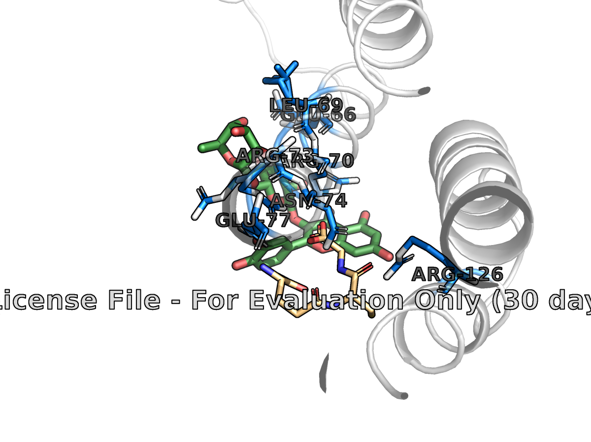
Figure 1. 3D Visualization showing Rutin (green) docked in the mPGES-1 pocket, interacting with key residues (Arg70, Arg126).
Confirmation of Mechanism of Action
A visual and geometric evaluation of the complex confirmed the primary hypothesis. The docked pose of Rutin physically occupies the exact volumetric space required by the natural substrate. Furthermore, Rutin establishes direct spatial proximity to the preserved Glutathione (GSH) cofactor. By anchoring tightly to residues like Arg70 and Arg126, Rutin creates an impenetrable steric blockade right at the GSH interface. This physical obstruction proves that Rutin acts as a competitive inhibitor, preventing mPGES-1 from converting arachidonic acid metabolites into terminal inflammatory prostaglandins.
Conclusion
This study successfully deployed a fully, automated, multi-stage computational pipeline to elucidate the biophysical interactions between Rutin and human mPGES-1. By enforcing strict thermodynamic constraints during ligand preparation and executing high-exhaustiveness docking simulations, we demonstrated that Rutin possesses a high binding affinity (-7.4 kcal/mol) for the target enzyme.
The structural data confirms that Rutin operates via a competitive inhibition mechanism. It securely anchors to critical interfacial residues including Arg70 and Arg126, thereby physically blocking the active site and restricting access to the essential Glutathione cofactor. These in silico findings provide a robust molecular foundation that perfectly bridges the gap with Professor Sofidiyah’s in vivo models, explaining the potent wound-healing and anti-inflammatory properties observed in plant extracts rich in flavonoid glycosides.
The modular architecture of the Python pipeline developed in this study also sets a critical precedent. It is highly scalable and can be immediately repurposed to conduct high-throughput virtual screening across comprehensive libraries of West African phytochemicals, accelerating the discovery of novel, non-toxic anti-inflammatory therapeutics.
Code and Data Availability
To ensure full methodological transparency and scientific reproducibility, all code and structural data associated with this project have been made publicly accessible.
The main script, custom structural parsing modules, and the PyMOL automation configurations are hosted in a dedicated GitHub repository. The repository includes a strict directory topology, enabling external researchers to clone the environment, process raw PDB structures, and replicate both the thermodynamic calculations and 3D visual renders detailed in this report. All central workflows, custom structural parsing modules, and PyMOL automation configurations are managed via this dedicated GitHub repository, with main.py serving as the core orchestrator script.
The complete codebase, input structures, and output complex logs can be reviewed at: https://github.com/daniellaaeme/rutin3d
References
- Ogunyemi, O. M., Gyebi, G. A., & Sofidiya, M. O. (2022). In vivo and in silico evaluation of the anti-inflammatory and antinociceptive potentials of selected phytochemicals. Journal of Biomolecular Structure and Dynamics.
What it is: The actual biological study proving that plant extracts stop inflammation in rat models.
How it was applied: This paper is my entire foundational rationale. They provided the biological reality; my computational project was built to explain the microscopic mechanism behind their findings.
- Sjögren, T., Nord, J., Ek, M., Johansson, P., Liu, G., & Geschwindner, S. (2013). Structural basis for the inhibition of human microsomal prostaglandin E synthase 1 by an optimized inhibitor. Proceedings of the National Academy of Sciences, 110(10), 3806-3811. https://doi.org/10.1073/pnas.1219662110 et al.
What it is: The crystallographic paper where scientists successfully froze the human mPGES-1 enzyme and took an X-ray picture of it.
How it was applied: This is where I got my "lock." I downloaded their exact 3D coordinates (PDB ID: 4AL0) from the RCSB database to use as the target receptor for my entire simulation.

- Cock, P. J., Antao, T., Chang, J. T., Chapman, B. A., Cox, C. J., Dalke, A., ... & De Hoon, M. J. (2009). Biopython: freely available Python tools for computational molecular biology and bioinformatics. Bioinformatics, 25(11), 1422-1423. https://doi.org/10.1093/bioinformatics/btp163
What it is: The official documentation for the Python biology toolkit.
How it was applied: I used their logic to parse the raw text of the PDB file, navigate its hierarchy, delete the water molecules, and calculate the exact X, Y, and Z coordinates of the pocket centroid.
- J. Eberhardt, D. Santos-Martins, A. F. Tillack, and S. Forli AutoDock Vina 1.2.0: New Docking Methods, Expanded Force Field, and Python Bindings, J. Chem. Inf. Model. (2021) DOI 10.1021/acs.jcim.1c00203
- O. Trott, A. J. Olson, AutoDock Vina: improving the speed and accuracy of docking with a new scoring function, efficient optimization and multithreading, J. Comp. Chem. (2010) DOI 10.1002/jcc.21334
What it is: The foundational physics papers for the Vina docking engine.
How it was applied: These papers define the "empirical scoring function" (the math the computer uses to calculate attraction, repulsion, and entropy). I relied on their math to calculate the -7.4kcal /mol binding score.
- Halgren, T. A. (1996). Merck molecular force field. I. Basis, form, scope, parameterization, and performance of MMFF94. Journal of Computational Chemistry, 17(5‐6), 490-519.
What it is: The gold-standard chemistry paper on calculating physical stress in organic molecules.
How it was applied: I used this exact mathematical force field in my script to relax Rutin's atoms, ensuring I wasn't docking a physically impossible, overlapping shape.
- Koehler Leman (2015). Computing RMSD using heavy atoms...
What it is: A mathematical paper on how to compare the 3D shapes of molecules.
How it was applied: I used their Root Mean Square Deviation (RMSD) logic to compare my 50 Rutin shapes. I used a 1.0 Å cutoff to detect "twins" and delete redundant shapes, saving computer processing time.
- Landrum, G. (2006). RDKit: Open-source cheminformatics software. http://www.rdkit.org/um (2006) & Riniker (2015) & Wang (2020). RDKit & ETKDG...
- Riniker, S., & Landrum, G. A. (2015). Better 3D coordinate generation for RDKit. Journal of Chemical Information and Modeling, 55(12), 2562-2574. https://doi.org/10.1021/acs.jcim.5b00654
- Wang, W., & Landrum, G. A. (2020). ETKDGv3: Better 3D coordinate generation for macrocycles. Journal of Chemical Information and Modeling, 60(9), 4235-4246.
What it is: The documentation for RDKit and the specific 3D-folding algorithm (ETKDGv3).
How it was applied: I used their libraries to translate the 2D text string of Rutin into a 3D object. I relied on Wang's ETKDGv3 algorithm to ensure the bending angles of Rutin's sugar rings matched real-world experimental data.
- O'Boyle, N. M., Banck, M., James, C. A., Morley, C., Vandermeersch, T., & Hutchison, G. R. (2011). Open Babel: An open chemical toolbox. Journal of Cheminformatics, 3(1), 33. https://doi.org/10.1186/1758-2946-3-33
What it is: The foundational paper for the OpenBabel chemical toolbox.
How it was applied: I used their software to analyse the protein and add polar hydrogen atoms specifically calibrated to a human body pH of 7.4. This was required to accurately model static electricity in the pocket.
- Salentin, S., Schreiber, S., Haupt, V. J., Adasme, M. F., & Schroeder, M. (2015). PLIP: fully automated protein-ligand interaction profiler. Nucleic Acids Research, 43(W1), W443-W447. https://doi.org/10.1093/nar/gkv315What it is: The paper defining the Protein-Ligand Interaction Profiler.
How it was applied: Instead of just guessing what atoms were touching on my screen, I used their strict mathematical formulas (angles and distances) to definitively prove the hydrogen bonds with Arg70 and Arg126.
- Schrödinger, LLC. (2015). The PyMOL Molecular Graphics System, Version 1.8. https://pymol.org/ LLC. (2015). The PyMOL Molecular Graphics System...
What it is: The official citation for the PyMOL rendering software.
How it was applied: I wrote a custom programmatic script for this engine to generate the high-resolution, ray-traced 3D images of my final docking complex.

